University of Tripoli

Faculty of Information Technology

Software Engineering Department

ITSE 413

Human-Computer-Interaction report

User Interface Design, Website and application Evaluation

Project of students:

Sanad AlArousi 2181801442

Sanad Hibiga

Mohamed

|  |  |
| --- | --- |
| Part 1: UI and Website Evaluation | Sanad Alarousi 2181801442 |
| Part 2: Design 3 UI pages for sport store  with high fidelity prototype | Mohamed Algood  2211846082  Sanad Ben-Ali  2211845060 |

This report takes the critical approach to study and learn the HCI main concepts, mainly Shneiderman's 8 Golden Rules. The report will focus on certain pages or interfaces to make efforts meaningful and achievable, as criticizing the entirety of a systems UI is not useful to the learning process for university students.

Alongside that an improvement suggestion will be given regarding each flaw in the design that contradicts the 8 Golden Rules.

As for reference, the 8 golden rules are:

1) Strive for consistency 2) Enable frequent users to use shortcuts 3) Offer Informative feedback

4) Design Dialogue to yield closure 5) Offers simple Error Handling 6) Permit Easy reversal of Actions 7) Support Internal Focus of Control 8) Reduce Short Term memory Load

This report is part of a semester project that has an Interface design using Figma. In which the colleagues will aim to make an interface that yields to the 8 Golden Rules of our dear strict friend Shneiderman.



‘Ben Shneiderman (born August 21, 1947) is an American [computer scientist](https://en.wikipedia.org/wiki/Computer_scientist), a Distinguished University Professor in the University of Maryland Department of Computer Science, which is part of the [University of Maryland College of Computer, Mathematical, and Natural Sciences](https://en.wikipedia.org/wiki/University_of_Maryland_College_of_Computer,_Mathematical,_and_Natural_Sciences) at the [University of Maryland, College Park](https://en.wikipedia.org/wiki/University_of_Maryland,_College_Park), and the founding director (1983-2000) of the [University of Maryland Human-Computer Interaction Lab](https://en.wikipedia.org/wiki/University_of_Maryland_Human-Computer_Interaction_Lab). He conducted fundamental research in the field of [human–computer interaction](https://en.wikipedia.org/wiki/Human–computer_interaction), developing new ideas, methods, and tools such as the [direct manipulation interface](https://en.wikipedia.org/wiki/Direct_manipulation_interface), and his eight rules of design‘

his Awards through his Career include: Member National Academy of Engineering, [ACM Fellow](https://en.wikipedia.org/wiki/List_of_Fellows_of_the_Association_for_Computing_Machinery), AAAS Fellow, IEEE Fellow, IEEE Visualization Career Award, SIGCHI LifeTime Achievement, Miles Conrad Award,

Strict man smiling :)

What are the 8 Golden Rules of HCI developed by Prof. Ben Shneiderman?

They are the guidelines In which designers have to follow to guarantee the quality of the Interfaces of the system.

# Rule1: Strive For Consistency:

## 1.1 **Internal consistency**:

It is the consistency amongst a systems apps, or pages.

Example: the position of the taskbar in all Microsoft365 apps is in the same place, and with the same order, and across all versions and batches or the applications.

## 1.2 **External Consistency**:

The consistency of system elements and services with the industry’s standards and minimums.

## 1.3 **Consistency Benefits on Users**:

* **Improves usability**: Consistent button designs (color, shape, size) make it easier for users to identify interactive elements.
* **Enhanced Learnability**: If users learn how to use one part of the system, they can apply that knowledge to other parts.
* **Increased Efficiency**
* **Reduced Errors**: if a delete button is always red and in the same location, users will not accidentally delete important information.
* **Better User Satisfactions**: Consistent interface provides a seamless experience throughout the times the users uses the system.
* **Easier Updates**: Consistent design patterns make it easier for developers to update and maintain the system.
* **Improved Accessibility**

# **Rule2: Enable *frequent users* to use Shortcuts**:

## 2.1 **Shortcuts Benefits on Users**:

* **Increased Frequent users Productivity**: in VS Code, these shortcuts when provided improves the productivity of developers: (“Shift+Alt+F” Organize Code, “Shift +” Zoom in, “Shit+alt+R” Reveal in File Explorer, …. etc)
* **Enhanced** Frequent Users **Satisfaction**: Experience users appreciate software that saves their time, such as the application or website remembers how many times the user “Ctrl+S” his work, thus changing the automatic save period to match his, and with some feedback of that, the user will have more satisfaction of working or using the system.
* **Reduced Cognitive Load** on Frequent Users: shortcuts that allows designers to switch between tools in image editing software can give the user more cognitive ability to focus on their work or tasks, rather than switch to the mouse to go click that same tool, example in GIMP: (“M” Move Tool, “Shift+S” Scale tool, “Z” Zoom tool)
* **Encouragement of** ‘***Advanced Use***’ for Frequent Users: after the past 3 benefits are achieved, and the user adopts the program, the frequent user will then invest part of his cognitive ability to learn some advanced features that enhances their overall capability and proficiency.
* **Customization and Personalization**: VS Code allows users to change the developer to edit the button patter for a shortcut to better meet his habits and their keyboard configuration, since some keyboard don’t have Fs or be split to 2.

# Rule3: Provide Informative Feedback:

* ****Increased Confidence****: When a user presses submit the form page should display a message or a pop-up with the result of the submission, this increases the trust of the user in the system.
* **Reduced Anxiety and Frustration**: When a page displays a progress bar or a loading animation the user knows that the system hasn’t crashed and his action is being processed, just like the time on traffic lights.
* **Enhanced Usability**: In a file upload interface, providing feedback like "File successfully uploaded" or "Error: File size exceeds limit" helps users understand what has happened and what to do next, making the system easier to use.
* ****Improved Learning and Mastery****: Interactive tutorials that provide real-time feedback, such as "Correct!" or "Try again," help users learn how to use the system more effectively, promoting better mastery of the interface.
* ****Error Prevention and Correction****: If a user enters an invalid email address during registration, an immediate feedback message such as "Please enter a valid email address" helps them correct the mistake right away, reducing the chances of errors and improving data quality.

# **Rule4: Design Dialogs to Yield Closure:**

every interaction or series of interactions should have a clear beginning, middle, and end, providing users with a sense of completion and satisfaction.

# Rule5: Offer Error Prevention and Simple Error Handling:

systems that are designed with this rule in mind, minimize the likelihood of user errors and provide clear, simple mechanisms for correcting errors when they do occur.

# Rule6: Permit Easy Reversal of Actions:

allowing users to easily undo their actions, providing them with the ability to correct mistakes without serious consequences. This principle ensures that users feel confident experimenting and using the system without the fear of making irreversible errors.

## 6.1 **Benefits on Users when following Rule6**:

* ****Increased Confidence and Willingness to Experiment**:** In graphic design software like Adobe Photoshop or GIMP, users can undo their last action or even series of actions by pressing "Ctrl + Z." or going back to the history menu and choosing where to go back in the design process. This allows them to try different design options without worrying about permanently altering their work.
* ****Encouragement of Exploration**:** In video games, the ability to reload a previous save or undo a recent action encourages players to explore different strategies and game-play options without the fear of permanent consequences.

# Rule7: Support Internal Focus of Control.

# Rule8: Reduce Short-Term Memory Load:

Interfaces that are more intuitive, efficient, and user-friendly, leads to a better overall user experiences and higher satisfaction.

Following these 8 Golden Rules when designing each component, gives the Interface many benefits and returns that is not limited to what was mentioned in the sub-sections of some Rules earlier, but also better sales, user retention, lower number of complaints, which is usually what matters to upper management.

|  |  |  |  |
| --- | --- | --- | --- |
| Component Kind | Rule Defiance | Problem Found | Suggested Improvements |
| Libyane School website: 1) Home Page | | | |
| 1.1 Nav Bar at the top of the website | | | |
| 1.1.1 BreadCrumbs | Rule 1 | Nav bar has a div of class =”overlay overlay-header” making its shape inconsistent with external industry standards, nor with the rest of components. | Remove the designated div to ensure consistency |
| 1.1.2 BreadCrumbs | Rule 1 | Div class=”nav-warp” has empty space to the left even on small screens of 750*750px, and on phone screens the navbar buttons lack external consistency with industry standards, the buttons are too close to each other causing the increase of miss-click by the user, which may lead to frustration. | Fixing the code or fixing the coder...perhaps getting a Front-End Developer is much better. |

|  |  |  |  |
| --- | --- | --- | --- |
| Component Kind | Rule Defiance | Problem Found | Suggested Improvements |
| Libyane School website: 1) Home Page | | | |
| 1.2 Containers ‘Main’ | | | |
| 1.2.1 Main Container | Rule 1 | Container have no internal consistency with the rest of the containers, the image has a black base making the 4 borders not equal, resulting in an ugly rectangle border shape unlike the rest of the containers across the website.  No external consistency with the trend, cluttered fully informal UI is from the past, more of the style of newspapers rather than websites. | Best to remove the style of newspapers and keep the main container minimalist and keen on call for registration rather than an informal big chunk of information with unneeded pictures of children.  Otherwise edit the picture to have no Black Base to match the container border with the rest of the containers throughout the website.  If no External consistency is possible due to Visual Identity design, Internal Consistency is a must. |
| 1.2.2 Main Container Buttons | Rule 3 | Buttons call for action yet the container provides no Informative Feedback of forwarding the user to an external app store page nor to another container to download the app. | Create an HTML shape that is connected to a hyperlink redirecting the user to either the app store of Google or Apple, Or remove the buttons from the main container |
| 1.2.3 Main Container | Rule 7 | The main container the user meets first when entering the website is very cluttered and doesn’t serve the purpose it was intended for putting it there in the first place, very pollutive, not much informal, causing Loss Of Focus] | Decrease the amount of images and text in the main container, keep it for Creating an account and downloading the applications of the website. Keep the slogan in a very subtle font and color to conserve consistency later on. |
| 1.2.4 Main Container | Rule 8 | Container not intuitive for that position, testimonials carousels or call for registration will help Reduce Short Term Memory Load | Keep the buttons and the registration form centered and more visual than the rest of the contents |

|  |  |  |  |
| --- | --- | --- | --- |
| Component Kind | Rule Defiance | Problem Found | Suggested Improvements |
| Libyane School website: 1) Home Page | | | |
| 1.3 Containers ‘Sub’ | | | |
| 1.3.5 “Our Team” Right Container class=”team-avatar” | Rule 1 | Lack of internal consistency with the rest of the containers, image having rounded edges that don’t submerge in the underneath informational container. Rest of containers and most other images are cornered edged not rounded, Font in the image is inconsistent with the rest of image’s font and inconsistent with other images and fonts across the website. Muddy designer taste. | Make image rectangular and free of text, or make it submerged in the underneath container. |
| 1.3.6 Right side Informational Container class=”team-content” | Rule 1 | Lack of internal consistency with other text boxes, the BG being grey marble-like colored, unlike the rest of the text boxes backgrounds across the website being pure white or transparent. | Keep internal consistency by defining an id for all Bgs that should be white and adding that to its divs across all website. |
| 1.3.7 Middle Image Container | Rule 1 | Both right and left containers consist of an image and informational box, the middle container is fully an image, lacking internal consistency with its neighbors. | Change the middle container to be of an image carousel of Libyan Syllabus covers, embedded with a hyperlink that leads to the registration or log in page. Abolish the symbols of clickable buttons at the bottom of the image. |
| 1.3.8 Left side Informational Container class=”team-avatar” | Rule 1 | Lack of internal consistency with the rest of the containers, image having rounded edges that don’t submerge in the underneath informational container. Rest of containers and most other images are cornered edged not rounded, Font in the image is inconsistent with the rest of image’s font and inconsistent with other images and fonts across the website. Muddy designer taste. | Make image rectangular and free of text, or make it submerged in the underneath container. Kill the designer before he reproduces. Sincerely, this report caused me a serious mental fatigue due to the disastrous design of the components and the website. A future improvement of the report should be to evaluate a perfectly designed website, to measure wether the student would recognize the Rules obeyed. |
| 1.3.9 Right side Informational Container class=”team-content” | Rule 1 | Lack of internal consistency with other text boxes, the BG being gray marble-like colored, unlike the rest of the text boxes backgrounds across the website being pure white or transparent. | Keep internal consistency by defining an id for all Bgs that should be white and adding that to its divs across all website. |
| 1.3.10 Black Empty container | Rule 1 | Lack of Consistency, the website have many containers cluttered with images and slogans, having a surprise empty container mid journey adds up to the frustration and misguidance of the visitor. | Remove the empty black container |
| 1.3.11 3 side by side containers | Rule 1 | Lack of internal consistency with the rest of the container |  |
| 1.3.12 3 side by side containers | Rule 8 | Using a wide variety of colors, symbols, and organizations of sub-containers within each other container, forces the user to hold too many information temporary. | Abolish the 3 containers and keep them within the registration process, or make a carousel with consisting of each package, or maybe limit the contrasting colors to not cause Loss of Focus for the user. |
| 1.4 Containers ‘Footer’ | | | |
| 1.4.1 Input Component “Search Bar” | Rule 1 | Lack of External consistency with the rest of industry standards and designs, a good example is [KhanAcademy](http://KhanAcademy.org/) website, they have the search Bar in the Nav bar alongside the Icon of their V-Identi and their courses. | Change its position to the top section of the main container, or keep it in the Navbar of the website to ease the reach of users to specific information they need about the school. |
| 1.4.2 Arrow Icons | Rule 1 | Lack of Internal Consistency with the rest of icons and symbols within the website, underneath the ‘main container’ the slogan has straight Grey lines, a consistency with that should be adhered across all website pages, rather than presenting new icons and shapes. | Change the icon from >--- to ______ |
| 1.5 Input Components | | | |
| 1.5.1 Fake Red/Blue button under 1.3.9 and 1.3.6 | Rule 1 | Lack of external consistency, all the websites when presenting you with an icon of a button to download an application, embeds a hyperlink to that application. The website keeps that icon as an image misleading the user to where to get the service. | Embed a hyperlink to image.  Embed a hyperlink to image. |
| 1.5.2 Download Buttons underneath 1.5.1s | Rule 1 | Lack of External Consistency, most download buttons are bright, mid sized and call for focus of the user. | Increase the size of the download buttons and make them of a different color grade than bloody red, otherwise embed their link to the images above them. |
| 1.5.3 “Register Now” Buttons inside 1.3.12 | Rule 1 | Lack of internal Consistency with the rest of buttons, this container buttons were placed inside of it, whereas the rest of containers had the buttons placed outside of it. | Make the entirity of the dev as a call for action, by embedding the link of the registration page to each and every div, enabling user to be redirected easily without mistaking the location of the buttons, especially that all 3 buttons lead to the same web page. |
| 1.6 Navigational Components | | | |
| 1.6.1 Testimonial Carousel | Rule 1 | Lack of internal consistency with the rest of the color pallet for the website and for the visual identity, that is by using the color #848484 only and specifically for the carousel | Remove the BG color of #848484 and keep it as transparent as possible, or perhaps use the same Grey marble-like color used in 1.3.9 and 1.3.6 |
| 1.6.2 Testimonial Carousel’s logo | Rule 1 | Lack of internal consistency with the rest of the logo shapes. All the logos were rectangular or rectangular like shaped, whereas here it is circular with a white ring, intending to increase contrast to catch the focus of the visitor, yet resulting in clutter and pollution. | Remove the Logo, keep the testimonials carousel containing only testimonials. |

|  |  |  |  |
| --- | --- | --- | --- |
| Component Kind | Rule Defiance | Problem Found | Suggested Improvements |
| Libyane School website: 2) Student Registration | | | |
| 2.1 Informational Components | | | |
| 2.1.1 Container div class=”BreadCrump-wrap” | Rule 1 | Unnecessary location of the information of being at the “Registration” as it is apparent from the above Navbar | Remove Container |
| 2.2 Input Components | | | |
| 2.2.1 Input Name field | Rule 1 | No external consistency with industry standards, rather than presenting the form to the user at once, the community of UI/UX has decided it is better to present parts of the form together, eliminating visual clutter and decreasing the chance of an error | Split the form into separate steps of inputting data. |
| 2.2.2 Input Name field | Rule 5 | Asking for the full name in 1 input field opens the chance for errors to occur | Split it to 4 different input fields, or make a limitation for characters or spaces in the field. |
| 2.2.3 Date of Birth input field | Rule 1 | Lack of External consistency, the standard is to make it a drop-down list not a literal calendar pop-up | Split the field to 3 different drop lists, year, Month and Day. |
| 2.2.4 Date of Birth input field | Rule 5 | The field accepts values from the future or from the far past | Put a limit for the calendar or the drop down lists. |
| 2.2.5 Upload (Birth Certificate, Personal Photo of student) | Rule 1 | Lack of external Consistency, most websites allow for the upload of such documents later on in the registration process or after creating a profile, as such documents might be sensitive or not be within hand for the user. | Move it to the end of the form, Make the field that receives the document larger easing drag and drop |
| 2.2.6 Upload (Birth Certificate, Personal Photo of student) | Rule 5 | Field has no limitations to the types and sizes of files you can upload. | Strict it to PDF or png images. |
| 2.2.7 Gender input field | Rule 1 | Industry has decided making this a radio button option to be more user-friendly than a drop down list, also limiting the number of clicks a user has to make | Radio Button for gender field |
| 2.2.8 Academic level fields | Rule 1 | Lack of external consistency, the standard is to make an optgroup rather than having 2 input fields | Either eliminate the first input field, or merge them into 1 and use optgroup to have it more visually appealing to the eye and user-friendly |
| Libyane School website: 3) Libyan Syllabus Application | | | |
| 3.1 Empty page with unnecessary button that doesn’t work | Rule 1 |  | Remove the entire page and allow paying in a different page at the website. |

|  |  |  |  |
| --- | --- | --- | --- |
| Turbo application 4) | | | |
| 4.1 Notifications | | | |
| Component Kind | Rule Defiance | Problem Found | Suggested Improvements |
| Informational | None |  |  |
| Navigational Components None |  |  |  |
| Pagination None |  |  |  |
| Containers | None |  |  |

|  |  |  |  |
| --- | --- | --- | --- |
| Turbo application 4) | | | |
| 4.2 Performance Score | | | |
| Component Kind | Rule Defiance | Problem Found | Suggested Improvements |
| Informational | Rule 4 | The user can’t Driver can’t understand his position compared to the rest of the Drivers, as most customers are prompted to give 5 stars by default and don’t care about giving a sincere feedback of their drivers, the score is usually inflated | Show the percntile of the driver in the “Driers Community”, show the number of drivers with such scores of Excellent, Good Fair etc.  Remove auto 5 stars evaluation of trips and drivers. |
| Navigational None |  |  |  |
| Pagination None |  |  |  |
| Containers | Rule 1 | Lack of consistency, Warnings container changes color with the number of warnings, whereas the Complains from Riders container even at 0 is still red, Excellent is put under Good, Invitations are yellow colored even though they aren’t a measurement of a Driver, I Have 164 Invitation and yet it is colored Yellow, Cancellation Rate is at 0% yet it is colored yellow, Acceptance Rate is colored Green even though its at 0% | Reorganize the containers to have them start from most important to last, revise the code behind the coloring to maintain the integrity of such a data, Users with no Warning or Complaints shouldn’t have to see their boxes appearing to them. |

|  |  |  |  |
| --- | --- | --- | --- |
| Turbo application 4) | | | |
| 4.3 Dashboard | | | |
| Component Kind | Rule Defiance | Problem Found | Suggested Improvements |
| 4.3.1 Informational History of income and trips | Rule 1 | Lack of consistency between the 2 history tabs, top shows per month, the underneath shows per week, yet they both don’t move together when going back or forward in time.  Lack of external consistency, as reports can be exported for each week, each month, each year or for the entire period of activity.  Many other issues of presenting data to the Drivers and informing them of their income in a proper way  it also doesn’t show the year of each month, being on the app for 2 years, I am unable to know which of the Julys I am seeing its data.  Many data is repeating it self. | Consult a PowerBI or Tablue engineer to make the data more presentable and useful to the user.  Both timeline containers should move together, as when going bak |
| 4.3.2 Bottom Informational Container | Rule 1 | Lack of consistency, as it works only with the weeks data not the month’s. |  |
| 4.3.3 Bottom Informational Container | Rule 4 | Data shown isn’t accurate, as it shows income not Net-Income, also it doesn’t show Turbo Fee value per week | Fix their back-end code to have it inform users with the data that matters to them |

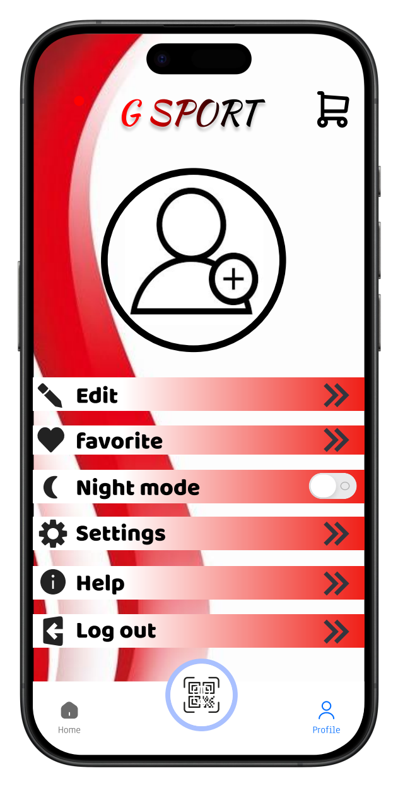

Part 2:

واجهة الإعدادات

1. الصورة الشخصية
2. التعديل
3. المفضلات
4. خيار المظهر الليلي
5. إعدادات البرنامج و الحساب
6. المساعدة
7. تسجيل الخروج

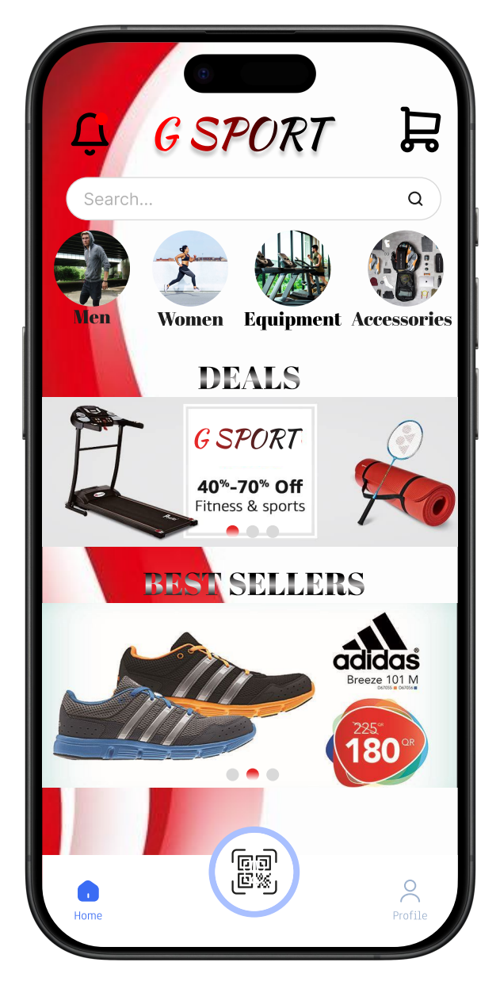

الواجهة الرئيسية

1. أيقونة الجرس: خاصة بإشعارات البرنامج
2. أيقونة السلة: خاصة بتجميع اختيارات ا لمتسوق
3. أيقونة الصفحة الرئيسية
4. أيقونة الملف الشخصي
5. أيقونة قارئ الباركود
6. شريط البحث

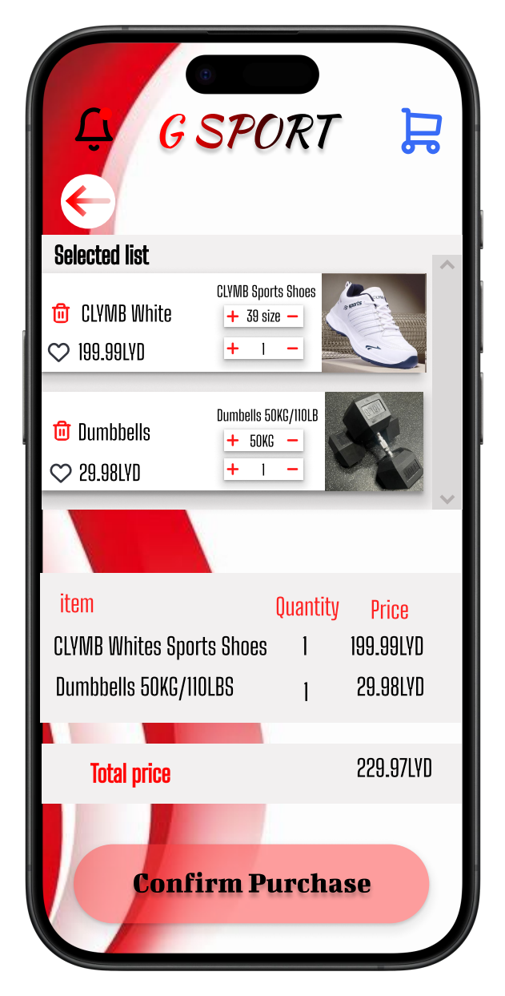

واجهة سلة المشتريات

1. قائمة الإختيارات
2. الفاتورة
3. سهم الرجوع لواجهة التسوق
4. زر التأكيد للشراء

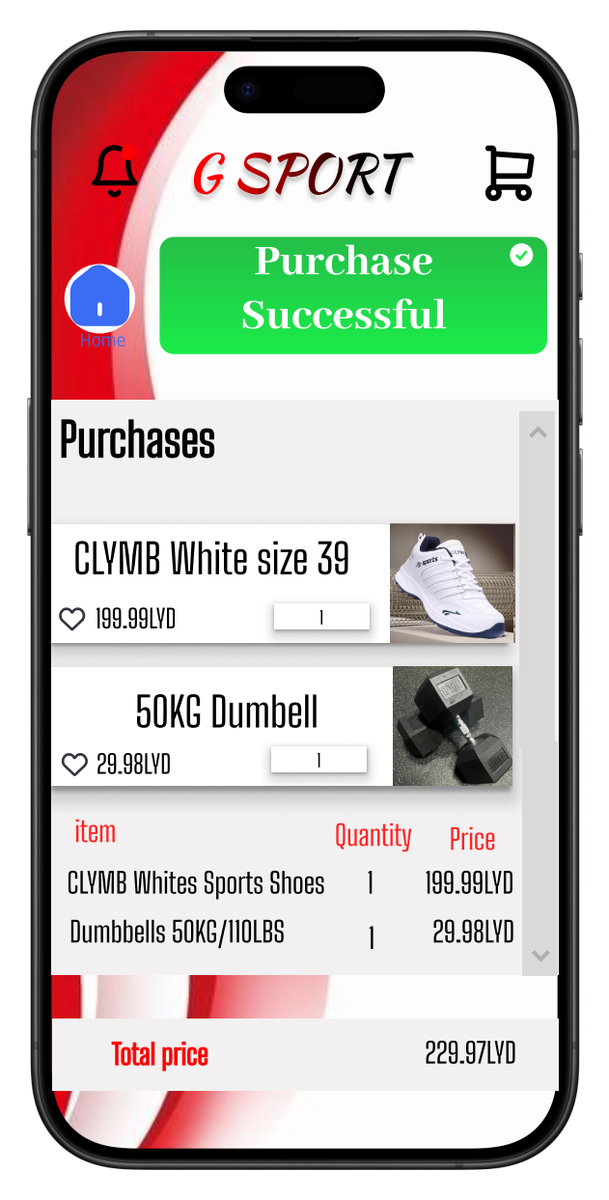

واجهة المشتريات

واجهة المشتريات:

18. اشعار تأكيد الدفع

19. تاريخ المشتريات

20. اجمالي ثمن المشتريات

21. زر الرجوع للواجهة الرئيسية